**Project Design Phase-II**

**Data Flow Diagram &User Stories**

|  |  |
| --- | --- |
| Date | 10 November 2022 |
| Team ID | PNT2022TMID20682 |
| Project Name | Virtual eye-LifeGuard for Swimmingpools to detect Active Drowning |
| Maximum Marks | 4 Marks |

**Data Flow Diagrams:**

A Data Flow Diagram (DFD) is a traditional visual representation of the information flows within a system. A neat and clear DFD can depict the right amount of the system requirement graphically. It shows how data enters and leaves the system, what changes the information, and where data is stored.

Example: DFD Level 0

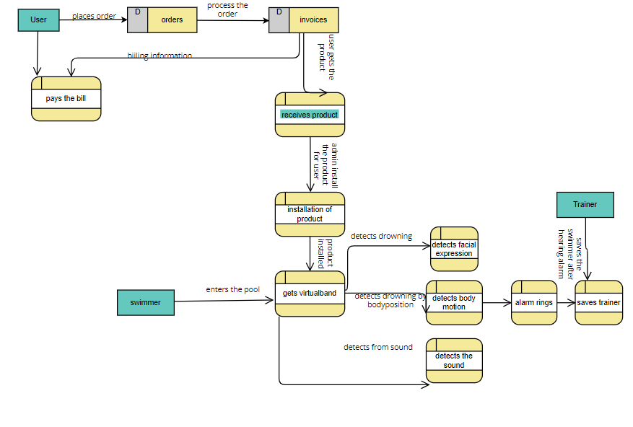

**User Stories**

Use the below template to list all the user stories for the product.

| **User Type** | **Functional Requirement (Epic)** | **User Story Number** | **User Story / Task** | **Acceptance criteria** | **Priority** | **Release** |
| --- | --- | --- | --- | --- | --- | --- |
| Customer | orders | USN-1 | As a user, I can order for virtual eye |  | High | Sprint-1 |
|  | Processing order | USN-2 | I get the invoice and order confirmation | I can receive confirmation and bill receipt | Medium | Sprint-1 |
|  |  |  |  |  |  |  |
|  |  | USN-3 | I pay for the virtual eye system | The payment is done | Medium | Sprint-1 |
| Admin | Installation |  | They set the camera and install and configure the system in swimming pools | The software is installed and cameras are setup | High | Sprint-1 |
|  |  |  |  |  | High | Sprint 2 |
| swimmers |  | USN-1 | The swimmers gets virtual wrist band before entering pool to monitor their health condition. | Virtual band is received |  |  |
|  | Detection of drowning | USN-2 | The system detects drowning by the face expression/by emotion of swimmers. | Detection of drowning | High | Sprint-2 |
|  |  | USN-3 | The system detects drowning by the sound made by swimmers | Detects drowning | High | Sprint-2 |
|  |  | USN-4 | The system detects drowning by the body motion of the swimmers | Detects drowning | High | Sprint-2 |
|  | Alarm rings |  | The alarm rings once the system detects active drowning | Alarm rings | High | Sprint -3 |
| Trainer | Saves lives |  | The trainer saves the swimmer who is drowning once the alarm rings | Saves the life of people | High | Sprint -3 |